Synchronous Motor and Generator Lab
ECEN 390
Seth Ricks
11/1/2025
Brother Swenson

Synchronous Motor and Generator Lab (52 Points + 2 Extra Credit)
(jas, Synchronous Motor and Generator Lab.docx, 9/01/2025)

Note: You can work in groups of up to three if desired for this LabVolt lab. Teams that have four or more persons make working with the equipment difficult. Submit an electronic version of a lab report to receive credit for doing this lab. The goal of your lab report is to provide sufficient documentation so that the lab can be repeated if necessary. Therefore, simply add to this document to arrive at your lab report, as all the explanatory text, procedures, and Discussion and Conclusion questions contained in this document are required for a complete lab report. So for your lab report, add a cover page that includes name or names, class and name of the lab. Also add in your results, and answers to the Discussion and Conclusions questions to the existing lab document. While you are to share all Procedure items with any lab partners, your Discussion and Conclusions section is to be uniquely yours. See the grading rubric at the end of this document for more details.

Purpose: The purpose of this lab is to become familiar with three-phase synchronous motors and generators.

Three-Phase Rotating Machines

A typical three-phase rotating machine is illustrated below in Figure 1. As shown, there are three separate stationary (stator) windings spaced 120˚ apart connected to the three different phases (A, B and C) of a three-phase power system. The result of this configuration is a resultant magnetic field produced by the stator windings that rotates at the frequency of the three-phase power, which is 60 Hz in the United States.

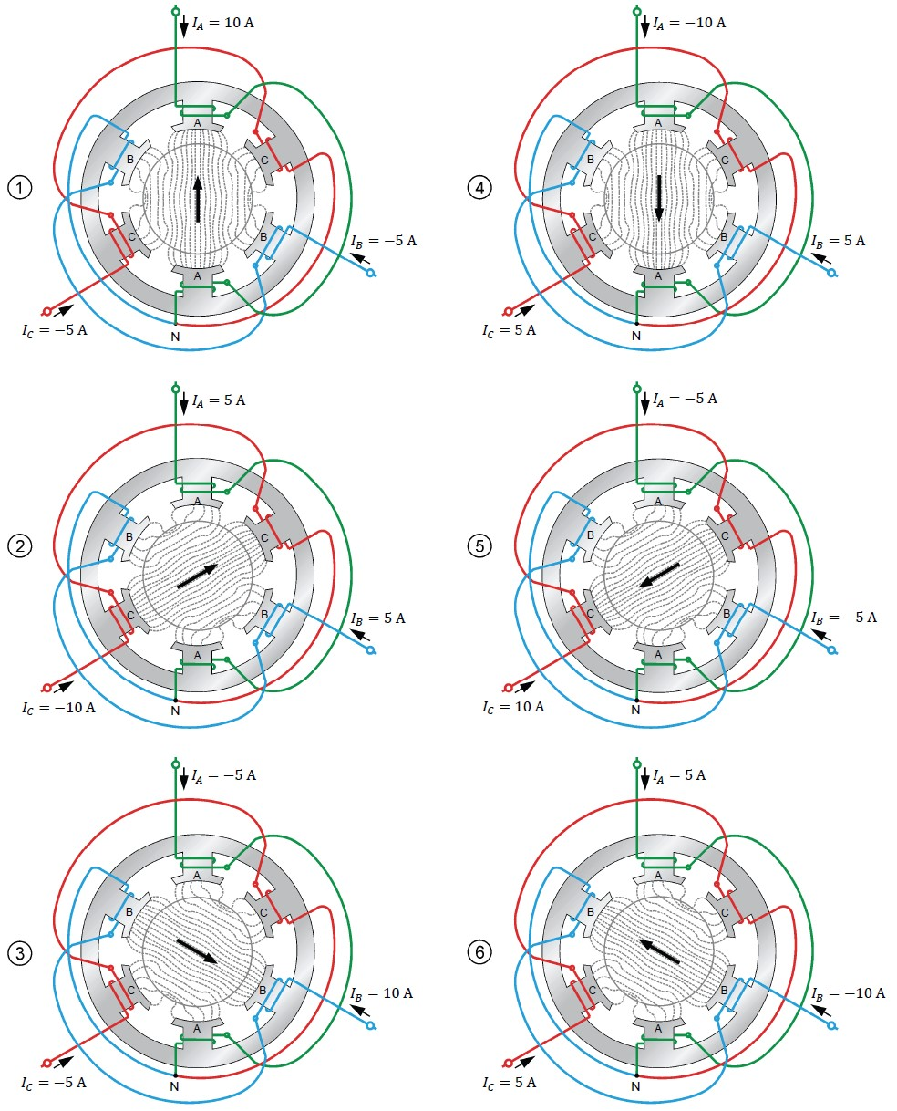
Figure 1: Position of the rotating magnetic field at various instants.

In a synchronous motor or generator, a DC field current is applied to windings on the rotor to produce an electromagnet with an adjustable magnetic field strength. A synchronous motor can be operated as a synchronous generator and vice versa. In a synchronous motor the rotor simply follows the rotating magnetic field of the stator, resulting in a rotor rotational speed that matches the rotational speed of the stator magnetic field. In a synchronous generator, voltages are induced in the stator windings when a prime mover rotates the rotor and its associated magnetic field. Another term besides stator and rotor that is commonly used with motors and generators in the armature, which refers to the part of a motor or generator that conducts AC current. With a synchronous motor or generator the stator windings conduct AC current, resulting in the stator windings also referred to as the armature windings.

In this lab the LabVolt Synchronous Motor/Generator unit will be operated first as a motor and then as a generator. The Four Quadrant Dynamometer/Power Supply unit will be used as a mechanical load for the motor, along with the prime mover for the generator.

Equipment

The following equipment will be used in this lab:

Power Supply Unit

The power supply unit is shown in Figure 2 and provides electrical power to most of the other LabVolt units. The power supply unit provides high-voltage AC and DC at fixed and variable voltage levels. The power supply unit also provides 24 V DC to power the Data Acquisition and Control Interface Unit (DAC Unit). A brief description of the essential elements of the power supply unit follows:
The main power switch for the Power Supply unit is in the upper left corner of the panel shown in Figure 2. This is the switch that turns on and off the high-voltage AC and DC power supplies. (Note: A | indicates the switch on position with a ◯ indicating the switch off position.) The main power switch is locked in the off position by a padlock that will need to be removed, then replaced when you are finished with a lab. To minimize the high-voltage hazard, keep the main high-voltage power switch of the Power Supply unit in the off position until you are ready to start an experiment, and then turn off this switch as soon as possible at the conclusion of a given experiment.

The auxiliary low-power supply switch is located at the bottom left of the Power Supply unit illustrated in Figure 2, and controls power to the two jacks just to the right of the switch. (Note: A | indicates the switch on position with a ◯ indicating the switch off position.) The auxiliary low-power supply provides power to the Data Acquisition and Control Interface (DACI Unit) by means of a thin power cable connected between the two units. Power must be supplied to the DACI Unit before running the Instrumentation and Control application on the lab computer. Hence, the auxiliary low-power supply is to be turned on at the start of each lab and left on until the lab is completed. Whereas the main power switch for the high-voltage supplies should be turned off whenever the high-voltage of those supplies is not required, such as when wiring up specific circuits.

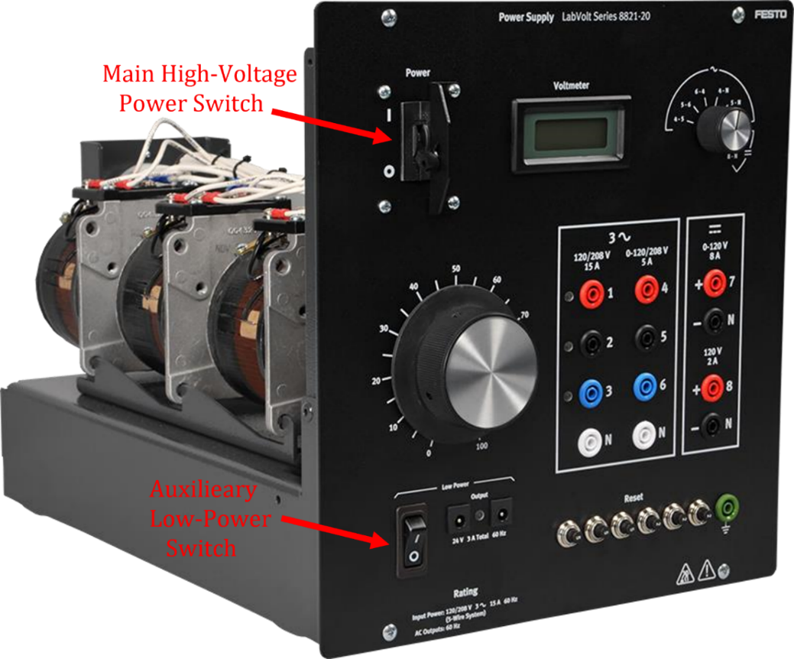
Figure 2: The LabVolt Power Supply Unit for providing fixed and variable AC and DC voltages.
The LabVolt power supply illustrated in Figure 2 provides both fixed and adjustable AC and DC output voltages. The left most column of front panel connectors labeled 120/208 V 15 A, provide a fixed 4-wire Wye (Y) connected source, with outputs labeled 1, 2, 3 and a neutral N. The middle column of front panel connectors labeled 120/208 V 5 A, provide an adjustable 4-wire Wye (Y) connected source, with outputs labeled 4, 5, 6 and a neutral N.
The large dial with an adjustment scale ranging from 0 to 100%, provides the adjustment for the AC and DC adjustable output voltages. The right most column of front panel connectors with the upper two connectors labeled 7 and N is an adjustable DC output voltage, while the lower two DC connectors in the right most DC output column labeled 8 and N provide a fixed DC output voltage as indicated.

The LCD voltmeter illustrated in Figure 2 works in conjunction with the selector switch to the right of the LCD display. The selector switch is to be rotated to the desired output voltage for display, with possible options being AC line-to-line voltages V₄₅ or V₅₆, or V₆₄, or AC phase voltages V_{4N} or V_{5N} or V_{6N}, or DC voltages V_{7N} or V_{8N}, with N referring to the Neutral side of the voltages. (Note, the Wye (Y) connected line-to-line or phase voltages associated with the connectors labeled 1, 2, 3 and N cannot be displayed on the LCD voltmeter associated with the LabVolt Power Supply unit.)

Several resettable overcurrent circuit breakers are located at the lower right of the panel. If your lab circuit is not receiving power, first check your connections, and then check for tripped overcurrent breakers, pushing in the button of a tripped breaker to reengage the power to the circuits.

Four Quadrant Dynamometer/Power Supply Unit

The dynamometer/power supply unit is shown below in Figure 3. It provides several precision-controlled resources for testing mechanical and electrical systems. For the mechanical, the dynamometer can operate as a mechanical load (or brake) or a prime mover (motor) with constant speed or constant torque. A brief description of the elements of the power supply unit will now be given.

The Four-Quadrant Dynamometer/Power Supply mainly consists of a permanent magnet DC motor, a four-quadrant power supply, and an onboard microcontroller. A toggle switch on the front panel allows selection of the operating mode (Dynamometer or Power Supply). In each operating mode, a wide variety of user selectable functions are available.
- In the Dynamometer operating mode, each function makes the module operate as a different type of device including a brake or mechanical load, a prime mover, and a small wind-turbine emulator. A pulley on the shaft of the permanent magnet DC motor allows mechanical coupling to any of the LabVolt rotating machines.
- In the Power Supply operating mode, each function makes the module operate as a different type of electrical source including a variable DC voltage source, a variable DC current source, a variable-voltage and variable-frequency AC power source, a battery charger, and a solar panel emulator. Two safety banana jacks on the front panel provide access to the terminals of the four-quadrant power supply.
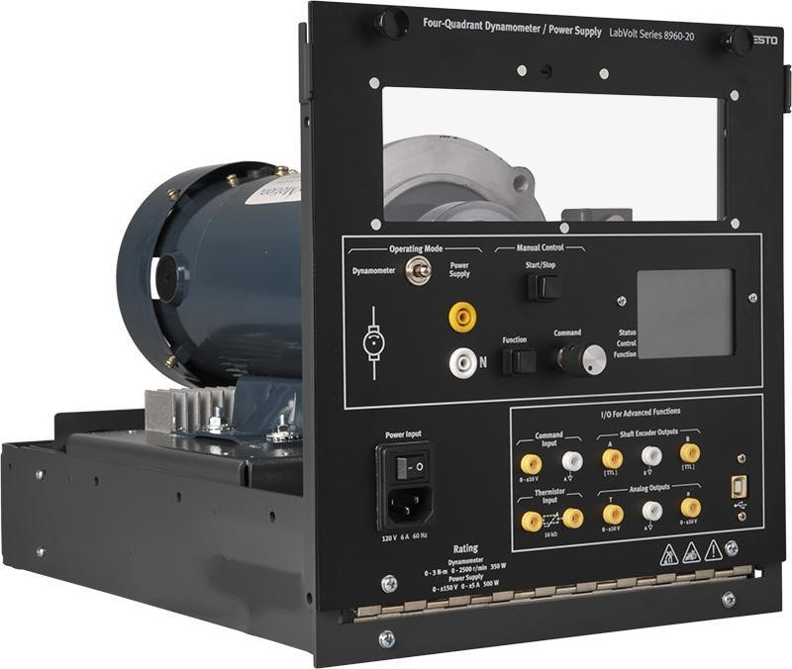
Figure 3: Four Quadrant Dynamometer/Power Supply.
The Liquid crystal display (LCD) shows the status, control mode, and selected function of the Four Quadrant Dynamometer/Power Supply, as well as the measured value of important parameters related to the currently selected function. The LCD display is also used to display important information related to the Four-Quadrant Dynamometer/Power Supply, such as faults and error messages.

In the lower right corner is the USB port connector. This connector allows the Four-Quadrant Dynamometer/Power Supply to be connected to a USB port of the computer running the LVDAC-EMS software.

Data Acquisition and Control Interface (DACI) Unit

The Data Acquisition and Control Interface (DACI) is shown in Figure 4. It provides the instrumentation interface between the LabVolt bench and the host computer which runs a virtual instrumentation and control application. The DACI unit has four voltage measurement inputs labeled as E1 through E4, with E corresponding to the measurement of an electromotive force, or emf. The DACI unit also has four current measurement inputs labeled I1 through I4, each offering either a 4 A or 40 A current range. In conjunction with the host software, many various AC or DC measurements can be made by means of the DACI, including voltage, current, power, impedance, phase angle and power factor.

The DACI unit requires a low-voltage power supply for operation. The power input jacks are located at the bottom center of the panel. The jacks are identical and are designed for daisy-chain of multiple units. Make sure that the thin-wire cable is connected between one of these jacks and the similar jacks located on the Power Supply unit. Power must be supplied to the DACI unit before running the Instrumentation and Control application on the lab computer. Turn off the low-voltage power supply switch on the Power Supply unit when a lab is completed.
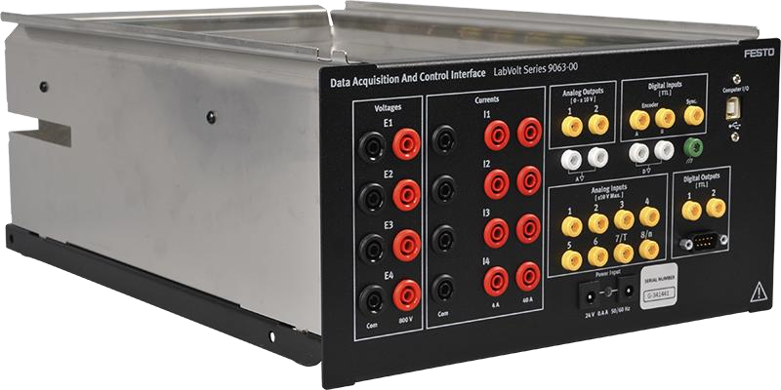
Figure 4: The Data Acquisition and Control Interface Unit.
Referring to Figure 4, the red and black front panel connectors associated with voltages E1 - E4 are the positive and negative voltmeter connections, respectively. For the current meters I1 – I4 shown in Figure 4, the two vertical sets of red front panel input connectors, corresponding to two different range options, 4 A or 40 A. Current meters I1 – I4 measure current by means of internal low-resistance sense resistors that convert current to voltage. Blowable fuses in series with low-resistance sense resistors are included to protect against excessive current flow. A blown fuse in a current measurement channel must be replaced to make a given channel functional. 5 A replacement fuses are available and can safely be replaced by making sure that the main power switch for the Power Supply unit is set to the off position (◯). The fuses can then be accessed and replaced by sliding the Data Acquisition and Control Interface unit partially out of the LabVolt chassis. Simply choose another current meter channel for measurements if no replacement fuses are available.

Resistive Load Unit
CAUTION: Make sure that you do not exceed the maximum current rating associated with each resistor, which will be the case if the applied voltage does not exceed 120 V DC or 120 V rms.
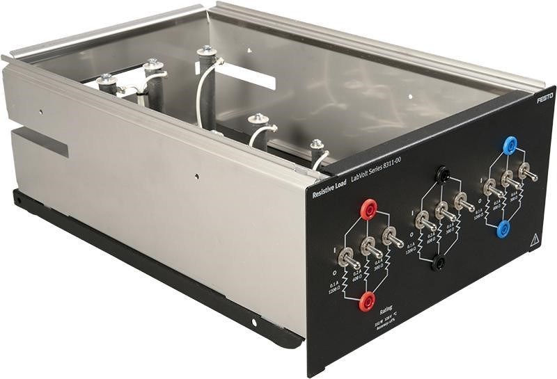
Figure 5: The Resistive Load Unit.

The Resistive Load Unit shown above in Figure 5 provides three banks of three parallel resistors that can be used to provide a balanced three-phase load. The three resistor values on each phase are 300 Ω, 600 Ω, and 1200 Ω. Each resistor is individually switched so that you can create various total resistor values. A switch in the up position inserts the associated resistor between the terminal connectors. Unless otherwise noted, we will create balanced three-phase loads, which means that the switch positions should be identical for all three banks of load resistors.

Synchronous Motor/Generator Unit

The LabVolt Synchronous Motor/Generator unit illustrated in Figure 6. Adjustable field current is provided by means of two DC excitation connectors and an onboard rheostat and control knob. The three stator windings are independent and can be configured either in a wye or delta configuration. Adjustable field current is provided by means of two DC excitation connectors and an onboard rheostat and control knob. The front panel of this machine can be opened to install a timing belt on the pulley to be mechanically coupled to the Four Quadrant Dynamometer/Power Supply unit. Hence the Synchronous Motor/Generator unit must be mounted adjacent to and to the right of the Four Quadrant Dynamometer/Power Supply unit to connect the timing belt. Modules in the LabVolt equipment rack may need to be rearranged to place the Synchronous Motor/Generator unit adjacent to and to the right of the Four Quadrant Dynamometer/Power Supply unit.

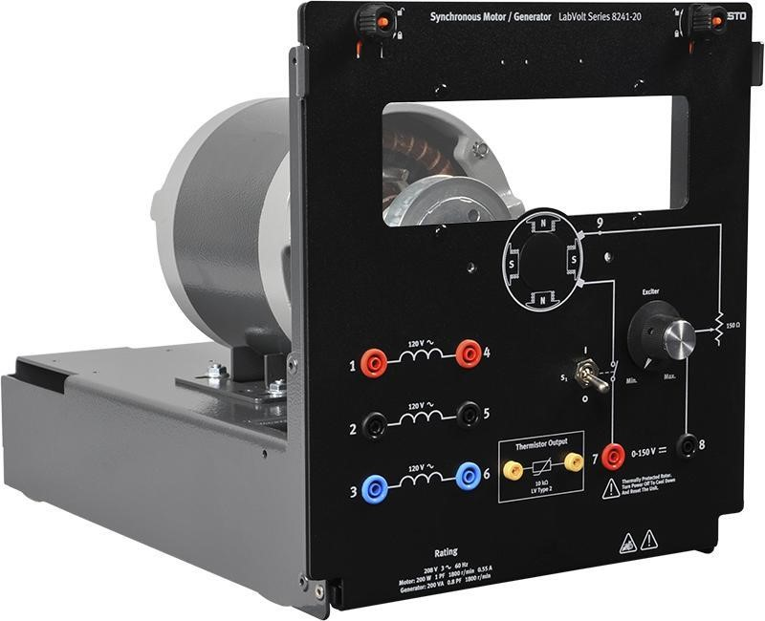
Figure 6: Synchronous Motor/Generator Unit.

Set-up and Connections
 High voltages are present in this laboratory exercise whenever the main power switch is on (upward position) on the Power Supply unit. To minimize the high-voltage hazard, keep the main high-voltage power switch of the Power Supply unit in the off position until you are ready to start an experiment, and then turn off this switch as soon as possible at the conclusion of a given experiment.

Also, before opening the front panels of both the Synchronous Motor/Generator unit and the Four-Quadrant Dynamometer/Power Supply to access the timing belt, make sure that power is turned off to prevent any machine from starting inadvertently.

The front panel of the Synchronous Motor/Generator unit can be opened to install a timing belt on the pulley to be mechanically coupled to the Four Quadrant Dynamometer/Power Supply unit. Hence the Synchronous Motor/Generator unit must be mounted adjacent to and to the right of the Four Quadrant Dynamometer/Power Supply unit to connect the timing belt. Modules in the LabVolt equipment rack may need to be rearranged to place the Synchronous Motor/Generator unit adjacent to and to the right of the Four Quadrant Dynamometer/Power Supply unit. Be careful when rearranging modules, as some of the modules are surprisingly heavy.

Part 1 – Synchronous Motor Testing

- Open the front panels of both the Synchronous Motor/Generator unit and the Four-Quadrant Dynamometer/Power Supply to make sure that the timing belt mechanically coupling the two units is properly installed. If needed, working the belt around one of the two spring loaded tension rollers of the Four-Quadrant Dynamometer/Power Supply will provide sufficient slack to remove the belt from one of the rotating machine pulleys. Make sure that the belt is again properly installed between tension rollers before closing the front panels of the Synchronous Motor/Generator unit and the Four-Quadrant Dynamometer/Power Supply.
- Make sure that the main High-Voltage Power switch on the Power Supply unit is set to the open (◯) position.
- Make sure that the main power switch on the Four-Quadrant Dynamometer/Power Supply is set the open (◯) position.
- Make sure that the 24 V AC power cable is connected between the Power Supply unit and the DACI unit, then turn on the 24 V AC power supply on the Power Supply unit. (Note: This 24 V supply does not present hazardous voltages as does the main power switch for the Power Supply unit, and so the 24 V supply does not need to be turned off until the lab is completed.)
- Connect the USB port of the Data Acquisition and Control Interface to a USB port of the host computer.
- Connect the USB port of the Four-Quadrant Dynamometer/Power Supply to a USB port of the host computer.
- Set the power supply switch for Four-Quadrant Dynamometer/Power Supply to the on (|) position and then set the Operating Mode switch to Dynamometer. (Note: The power supply switch for Four-Quadrant Dynamometer/Power Supply does not need to be turned off unless adjusting the coupling belt or until the lab is completed.)
- Turn the host computer on and then start the LVDAC-EMS software application. In the LVDACEMS start-up window, make sure that the Four-Quadrant Dynamometer/Power Supply Data Acquisition along with the Control Interface Unit are both detected by the software. Set the Local Network Voltage and Frequency to 120 V and 60 Hz, corresponding to the voltage and frequency of our AC power network. Next click OK to close the LVDAC EMS start-up window.
- Connect the equipment as shown below in Figure 7, which includes a wye connected three-phase motor with the Four-Quadrant Dynamometer/Power Supply providing a mechanical load.
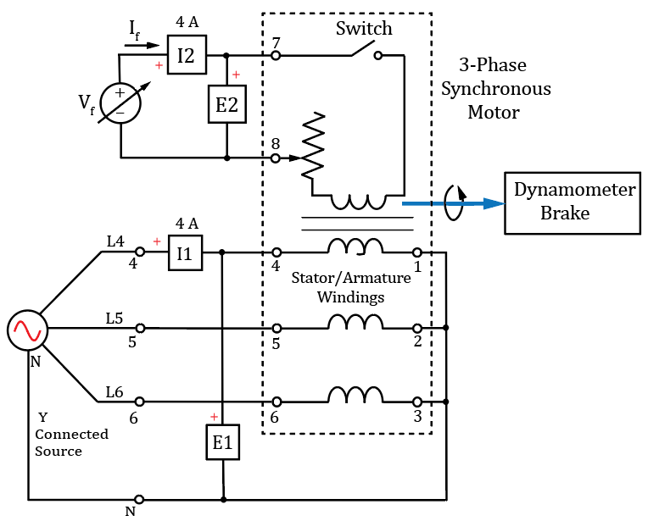
- Schematic for the 3-Phase Synchronous Motor Setup.

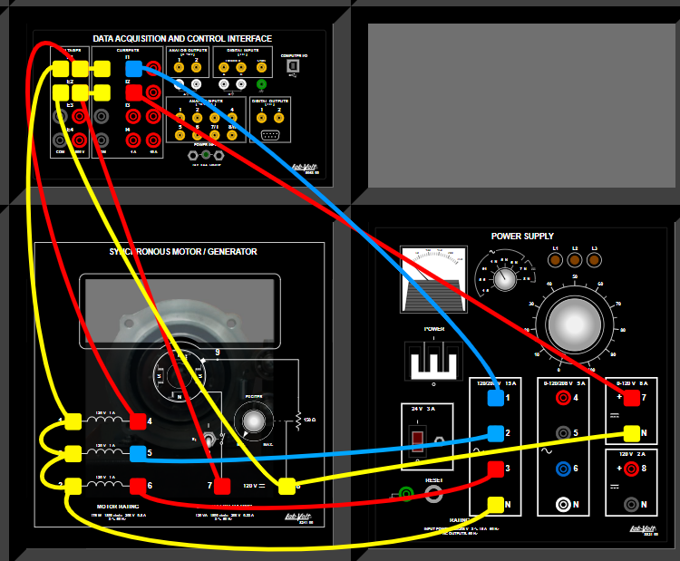
- Wiring Diagram for the 3-Phase Synchronous Motor Setup.

Figure 7: (a) Schematic for the 3-Phase Synchronous Motor and Dynamometer. (b) Wiring Diagram for the 3-Phase Synchronous Motor and Dynamometer.

- In the LVDAC-EMS application, select Instruments Metering, and set up the meters as follows: Configure meter M1 to measure the rms value (AC) of the motor armature voltage E1 and M2 to measure the current I1. Configure meters M3 and M4 to measure the DC field voltage E2 and DC field current I2, respectively. Be sure to set up meters M3 and M4 to measure DC rather than AC quantities. Set meter M5 to measure the active power associated with the field voltage and current, i.e., PQS2(E2,I2) with the Mode equal to P. Set M6 to measure the active power supplied to the motor PQS1(E1,I1) by choosing Mode P in the Meter Settings window, and M7 to measure the reactive power supplied to the motor PQS1(E1,I1) by choosing Mode Q in the Meter Settings window.
- In the LVDAC-EMS open the Four-Quadrant Dynamometer/Power Supply window and make the following settings:
  - Set the Function parameter to Two-Quadrant, Constant-Torque Brake.
  - Set the Torque parameter to 0.0 N⋅m.
  - Set the Pulley Ratio parameter to 24:24.
  - Toggle the Start/Stop button in the Four-Quadrant Dynamometer/Power Supply.

In the following procedure several measured values are to be recorded. Hence, an LVDAC-EMS Data Table is to be set up to streamline the data collection process. In the Data Table.

- In the LVDAC-EMS application select Tools Data Table which opens a table that allows the automatic recording of various LabVolt instrument values.
- Next select Options Record Settings Settings Four-Quadrant Dynamometer/Power Supply to bring up a list of available Dynamometer measurements for recording into the Data Table. Check the boxes to include Speed, Torque and Power in your Data Table. This operation also results in the remaining meter measurement names being imported into the rest of the columns, as illustrated below in Figure 8.
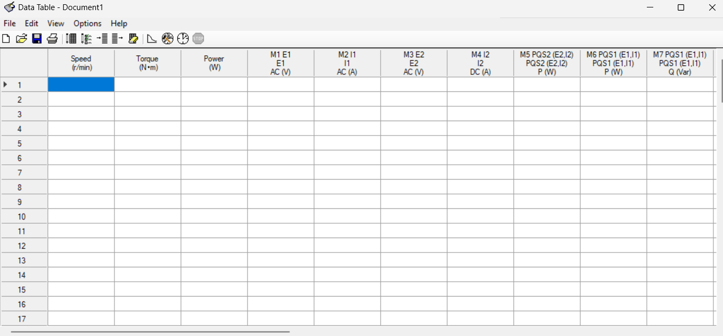
Figure 8: Data Table Set Up Prior to Recording Motor Measurements.

- On the Synchronous Motor/Generator, rotate the Exciter rheostat knob to the Min position and set the Exciter Switch to the closed (|) position.
- Rotate the large Power Supply Variable Voltage Control knob to approximately 80%, i.e., 80 on the scale from 0 to 100 for initial motor starting.
- On the LabVolt Power Supply unit, set the LCD voltmeter selector switch to select the adjustable DC V_{7N}, to display the adjustable DC voltage applied to the field windings of the generator.
- Turn on the main power switch of the LabVolt Power Supply unit which should start the three-phase synchronous motor spinning.
- Adjust the Synchronous Motor/Generator, Exciter knob and the Power Supply Variable Voltage Control knob as necessary to achieve a DC field current (I2) of 0.500 ±0.003 A, i.e., field current values ranging between 0.497 and 0.503 A. (Hint: Use the Synchronous Motor/Generator, Exciter knob as a course adjustment followed by the Power Supply Variable Control knob as the fine adjustment.) The Four-Quadrant Dynamometer/Power Supply window should display a speed between 1798 to 1802 r/min and a non-zero offset torque between 0.2 and 0.3 N⋅m for a torque setting at 0.0 N⋅m. (Note: The LVDAC-EMS software designates revolutions per minute as r/min, whereas this document favors representing revolutions per minute as rpm.)
- When you are satisfied with the displayed measurements, select Edit Record Data, to record the data in the LVDAC-EMS software Data Table for the torque setting at 0.0 N⋅m, noting that the actual torque measured and recorded will be between 0.2 and 0.3 N⋅m. (Note: You can delete a row of measured data in the Data Table by choosing Edit Delete Row, and then retake the data if needed.)
- Repeat steps 18 - 19 for Dynamometer Torque settings of 0.4 N⋅m, 0.5 N⋅m, 0.6 N⋅m, 0.7 N⋅m and 0.8 N⋅m. (Note: Make sure the Dynamometer Torque reading gets updated to the new torque setting prior to recording the data in your Data Table, which should have 6 rows of measured data.
- When completed with your Data Table measurements, turn off the main power switch of the LabVolt Power Supply unit. In the Dynamometer Settings change the Function Selection to CW Constant-Speed Prime Mover/Brake, to configure the Dynamometer as a motor (Prime Mover) for the next section of the lab.
- While there may be better approaches to getting the data from the LVDAC-EMS software Data Table into Microsoft Word for your lab report, the following approach works. In the LVDAC-EMS software Data Table, select File Export Save as type Comma-Separated Values Files (*.csv), which is a file that can be opened in Microsoft Excel. Open the file in Excel, then highlight and copy the desired data cells, to be pasted into Microsoft Word. In Word, select a blank location in your document and chose Paste Paste Options Use Destination Styles (S), which creates a new table of the desired data in Word. The desired data in this new table can then be copied and pasted into the desired empty cells of Table 1 below by choosing Paste Paste Options Overwrite Cells (O). The LVDAC-EMS software File Export Save as type Comma-Separated Values Files (*.csv) function includes text column headings in the cvs file. Be award the header text for power measurement commands such as PQS1(E1,I1) may spill over into an adjacent column in the cvs file, resulting in more column headings than columns of measured data. While this can be confusing, know that the numerical column data always corresponds to the order defined in your Data Table, even when the column headings are wrong.
- Paste individual columns of data for your Generator Characteristics versus Prime Mover rpm data from the LVDAC-EMS software Data Table into Table 1 below, noting that your Data Table has more columns of data and a different column order than Table 1 below. (16 points total.)
Table 1: LabVolt 3-Phase Synchronous Motor Measurements.
n  (rpm) | Torque  N⋅m | P_{Dyno}  (W) | E1 = E_{a}  (V) | I1 = I_{a}  (V) | E2 = V_{f}  (V) | I2 = I_{f}  (A) | P_{a}  (W) | P_{f}  (W) | Q_{a}  (VAR)
1801 | 0.28 | 52.88 | 119.8 | 0.389 | 80.57 | 0.502 | 40.64 | 23.03 | 6.175
1800 | 0.401 | 75.61 | 119.3 | 0.432 | 80.39 | 0.5 | 40.37 | 30.49 | 4.378
1800 | 0.502 | 94.61 | 119.6 | 0.473 | 80.39 | 0.5 | 40.38 | 38.46 | 4.364
1800 | 0.6 | 113 | 119.6 | 0.514 | 80.39 | 0.5 | 40.39 | 44.43 | 4.256
1801 | 0.702 | 132.5 | 119.4 | 0.555 | 80.35 | 0.498 | 40.21 | 51.07 | 4.519
1800 | 0.804 | 151.5 | 119.4 | 0.599 | 80.35 | 0.5 | 40.34 | 57.45 | 4.925

- In the Data Table window, Select Edit Clear Data Table, to clear the table for new values in the next portion of the lab.

Part 2 – Synchronous Generator

Three-phase synchronous generators produce most of the electricity used today, and are found in all electrical power generating stations, whether they are hydroelectric, diesel, coal fired, wind turbine, or nuclear facilities. Three-phase synchronous generators, referred to as alternators, also produce electricity in standard internal combustion engine motor vehicles. The three-phase AC voltage from a car alternator is converted to a DC voltage for battery charging and other DC vehicle loads. Rectified three-phase provides a larger average voltage with much lower ripple voltage than rectified single-phase AC.

The basic principle of operation of three-phase synchronous generators can be illustrated using the simplified single-phase synchronous generator shown in Figure 9.
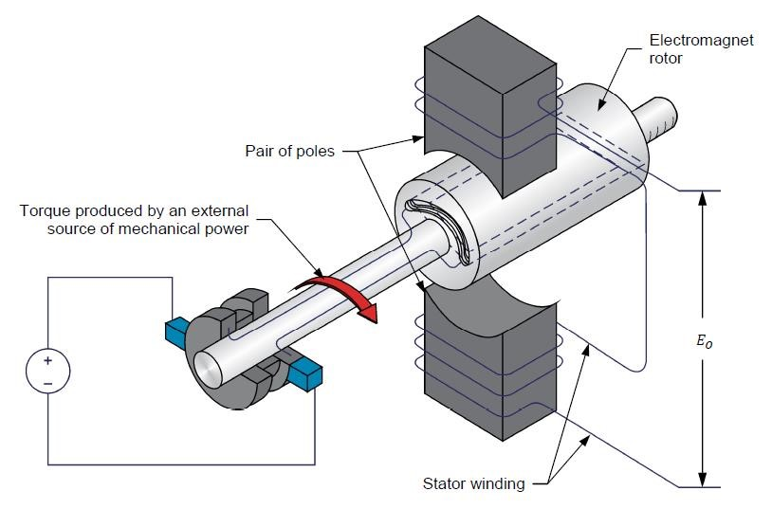
Figure 9: Simplified Single-Phase Synchronous Generator.
In the synchronous generator illustrated in Figure 9, DC current flowing in the rotor field windings result in the rotor becoming an electromagnet. The electromagnet rotor is coupled to a turbine which when exposed to an external source of mechanical power such as wind or water spins the rotor, resulting in an induced AC voltage in the stator windings. The synchronous generator thus converts mechanical power to AC electrical power, with an efficiency that is greater than most other forms of energy conversion.

In three-phase synchronous generators, the larger the rate of change of magnetic flux linking the stator windings, the larger the magnitude of the induced voltage in the stator windings. The rate of change of the magnetic flux linking the stator windings can be increased by increasing the magnitude of the rotor magnetic field by means of the DC field current, and/or by increasing the rotational speed of the rotor. Hence, the amplitude of the voltages produced by a three-phase synchronous generator is proportional to the rotor speed, and to the magnitude of the DC field current I_{f}.

- Connect the equipment as shown below in Figure 10, with the generator windings and load resistors connected in a wye configuration.
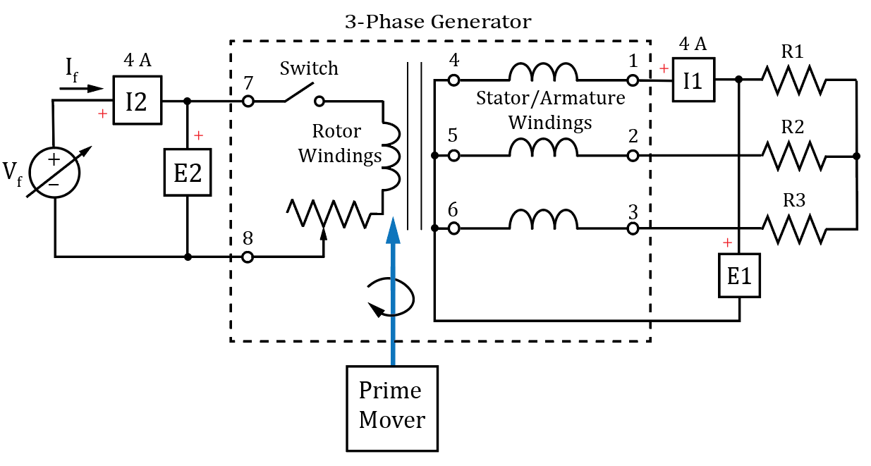
(a) Schematic Diagram of the 3-Phase Synchronous Generator Setup.

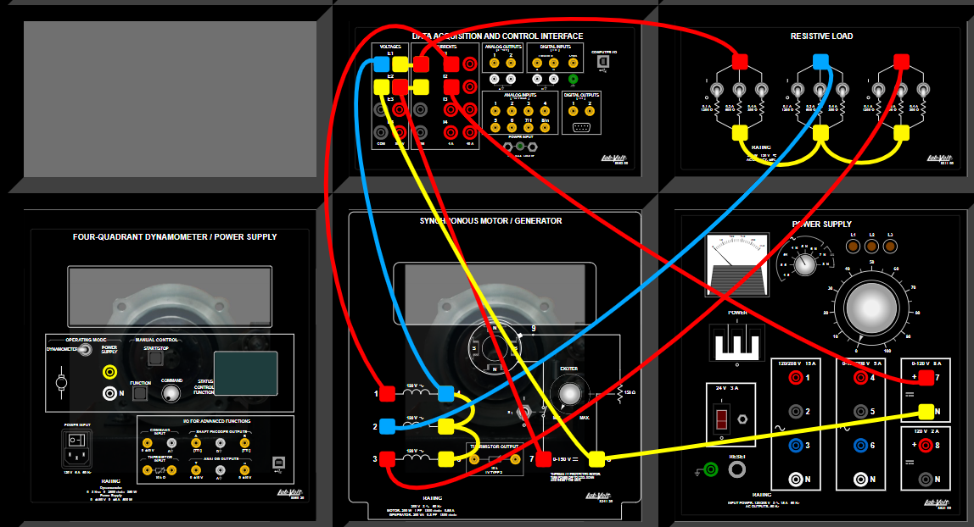
(b) Wiring Diagram of the 3-Phase Synchronous Generator Setup.

Figure 10: (a) Schematic Diagram of the 3-Phase Synchronous Generator Setup. (b) Wiring Diagram of the 3-Phase Synchronous Generator Setup.

- Configure the Resistive Load module switches for 600 Ω on each bank.
- In the LVDAC-EMS application, open the Four-Quadrant Dynamometer/Power Supply window, and then make or verify the following settings:
- Set the Function parameter to CW Constant-Speed Prime Mover/Brake.
- Set the Speed parameter of the Four-Quadrant Dynamometer/Power Supply to 1800 rpm, corresponding to an input power frequency of 60 Hz.
- Set the Pulley Ratio parameter to 24:24.
- In the LVDAC-EMS application, select Instruments Metering, and configure meters M1 and M2 to measure the rms value (AC) of the generator output voltage E1 and rms output current I1. Configure meter M3 to measure the Power associated with the armature voltage and current, i.e., PQS1(E1,I1) with the Mode equal to P. Configure meters M4 and M5 to measure the DC field voltage E2 and DC field current I2, respectively. Then configure meter M6 to measure the Power associated with the field voltage and current, i.e., PQS2(E2,I2) with the Mode equal to P. And finally configure meter M7 to measure the electrical frequency f_{e} of the generator output voltage E1, i.e., Frequency f(E1).
- On the Synchronous Motor/Generator, set the Exciter Switch to the closed (|) position and rotate the Exciter knob to the Min position.
- On the LabVolt Power Supply unit, set the LCD voltmeter selector switch to select the adjustable DC V_{7N}, to display the adjustable DC voltage applied to the field windings of the generator.
- Turn on the main power switch of the LabVolt Power Supply unit, then adjust the DC
voltage V_{7N} equal to approximately 70 V DC.
- In the Four-Quadrant Dynamometer/Power Supply window, click on the Start/Stop button to start the Prime Mover. Verify that the speed indicated in the dynamometer window is 1800 ± 3 rpm. If the recorded speed is not within ± 3 rpm of your set value, verify that the Function parameter in the Four-Quadrant Dynamometer/Power Supply window is set to CW Constant-Speed Prime Mover/Brake.
- Next adjust both the Synchronous Motor/Generator, Exciter Knob and the Power Supply Variable Voltage Control knob to achieve a synchronous generator output voltage E1 equal to approximately 120 V line-to-neutral, which requires a DC field current in the range of 0.5 to 0.6 A.
- Record the resulting electrical frequency f_{e}, i.e., f(E1), of the generator voltage E1 below using at least three significant figures including units.

f_{e} = 60 Hz (2 points.)

Generator Performance versus Prime Mover Speed

In the following procedure several measured values are to be recorded. Hence, an LVDAC-EMS Data Table is to be set up to streamline the data collection process.

- In the Four-Quadrant Dynamometer/Power Supply window, set the Speed parameter to 1000 rpm.

In the following procedure several measured values are to be recorded. Hence, an LVDAC-EMS Data Table is to be set up to streamline the data collection process.

- In the LVDAC-EMS application select Tools Data Table which opens a table that allows the automatic recording of various LabVolt instrument values.
- Next select Options Record Settings Settings Four-Quadrant Dynamometer Power Supply to bring up a list of available measurement names for that device. Check the boxes to include measurements of Dynamometer Speed and Power in the Data Table, which results in the Four-Quadrant Dynamometer/Power Supply measurements of Speed and Power occupying the 1st and 2nd columns of your Data Table. This operation also results in the defined meter measurement automatically added to the Data Table as illustrated below in Figure 12.
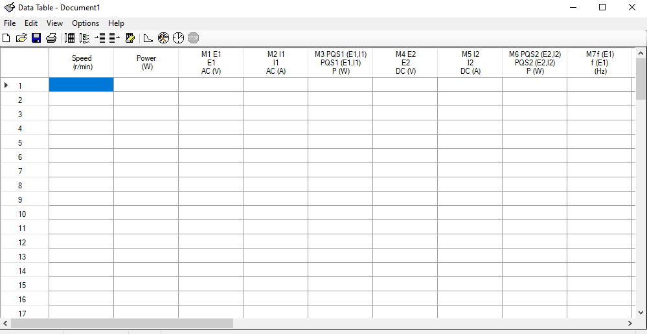
Figure 12: Data Table Set Up Prior to Recording Generator Measurements.

- Verify that the switches of the Resistive Load module are set to provide 600 Ω load per phase to the generator.
- Start the Prime Mover, by clicking on the Start/Stop button in the Four-Quadrant Dynamometer/Power Supply.
- Adjust both the Synchronous Motor/Generator, Exciter knob and the Power Supply Variable Voltage Control knob as necessary to achieve an I2 DC field current of 0.500 ±0.003 A, i.e., field current values ranging between 0.497 and 0.503 A. (Note: Use the Synchronous Motor/Generator, Exciter knob as a course adjustment followed by the Power Supply Variable Control knob as the fine adjustment for field current.)
- Select Edit Record Data, to record the data in the LVDAC-EMS software Data Table for the designated field current setting.
- In the Four-Quadrant Dynamometer/Power Supply window, increase the Speed parameter by 100 rpm, while maintaining the I2 DC field current between 0.497 and 0.503 A, and then click on Record Data record the corresponding data in your Data Table.
- Repeat step 9 to acquire data in your Data Table for speeds of 1100, 1200, 1300, 1400, 1500, 1600, 1700, 1800 and 1900 rpm, resulting in 10 rows of data in your Data Table. (Note: If the measured rpm values in your Data Table are more than ±3 rpm different from the set value, then verify that the Function parameter in the Four-Quadrant Dynamometer/Power Supply window is set to CW Constant-Speed Prime Mover/Brake, and retake data as necessary.)
- When you have recorded data in your Data Table for each of the 10 different speed values ranging from 1000 rpm to 1900 rpm, stop the Prime Mover, by clicking on the Start/Stop button in the Four-Quadrant Dynamometer/Power Supply.
- In the LVDAC-EMS software Data Table, select File Export Save as type Comma-Separated Values Files (*.csv), which is a file that can be opened in Microsoft Excel, and read by MATLAB for plotting.
- Paste your Generator Characteristics versus Prime Mover rpm data from the LVDAC-EMS software Data Table into Table 2 below. (Note: The measured dynamometer power values are negative per the passive sign convention, which assigns positive values to dissipated power and negative values to generated power. Also, the total electrical power provided by the three-phase generator is 3P_{a}.) (9 points total.)

Table 2: LabVolt 3-Phase Generator Measurements at Various rpm Values.
n  (rpm) | P_{Dyno}  (W) | E1 = E_{a}  (V) | I1 = I_{a}  (A) | P1 = P_{a}  (W) | E2 = V_{f}  (V) | I2 = I_{f}  (A) | P2 = P_{f}  (W) | f(E1) = f_{e}  (Hz)
1001 | -25.57 | 62.38 | 0.104 | 6.463 | 75.35 | 0.506 | 38.27 | 33.34
1101 | -30.28 | 68.15 | 0.117 | 7.926 | 74.37 | 0.501 | 37.44 | 36.65
1200 | -36.43 | 74.27 | 0.127 | 9.404 | 74.41 | 0.5 | 37.4 | 40
1301 | -41.93 | 80.51 | 0.137 | 11.02 | 74.33 | 0.501 | 37.44 | 43.35
1401 | -47.71 | 86.63 | 0.147 | 12.72 | 74.35 | 0.502 | 37.46 | 46.66
1500 | -54.77 | 92.93 | 0.158 | 14.66 | 74.45 | 0.504 | 37.67 | 50.04
1601 | -60.42 | 98.77 | 0.168 | 16.54 | 73.91 | 0.502 | 37.23 | 53.36
1700 | -68.59 | 104.9 | 0.178 | 18.64 | 73.91 | 0.502 | 37.26 | 56.68
1800 | -77.02 | 111 | 0.189 | 20.9 | 73.96 | 0.503 | 37.34 | 60.03
1900 | -84.12 | 117.2 | 0.199 | 23.24 | 73.83 | 0.505 | 37.41 | 63.35

- After saving your Data Table values to an appropriately named .csv file, select Edit Clear Data Table in the Data Table window to clear the table for new values in the next portion of the lab.
- Next import your Generator Characteristics versus Prime Mover rpm data into MATLAB for plotting results as shown below in Figure 13. MATLAB can directly import .csv files using the readmatrix() function. For example, given that the LVDAC-EMS software Data Table was exported as a .csv with file name LabVolt Generator rpm Data1.csv, the following readmatrix() function will import the desired rows and columns of saturation data from the .csv file:

rpm_dat = readmatrix('LabVolt Generator rpm Data1.csv', 'Range','A4:I13');

In MATLAB, the colon (:) operator provides a convenient way to separate out individual rows and columns of an array. For example, for a 5 X 5 matrix x, the 3rd column can be separated out using the notation Col3 = x(:,3).
- From your imported LabVolt Generator rpm data, plot the armature voltage E1 = E_{a} on the y-axis versus the rotor speed n in rpm on the x- axis. Include an x-axis label of “Rotational Speed (rpm)” using the xlabel() function. Include a y-axis label of “E_{a} (Vrms)” using the ylabel() function. (See MATLAB help on “subscripts in Axis labels”, on the xlabel() function to see how to incorporate subscripts.) Also add a title of “LabVolt Synchronous Generator Armature Voltage versus Rotational Speed – Your Name”. For the armature voltage E_{a} trace include markers for each data point in your plot (Search for plot, i.e., 2-D line plot, and then scroll down to Marker to see how to include data point markers in your MATLAB plot.)
- Replace the figure below with your version. (5 Points.)
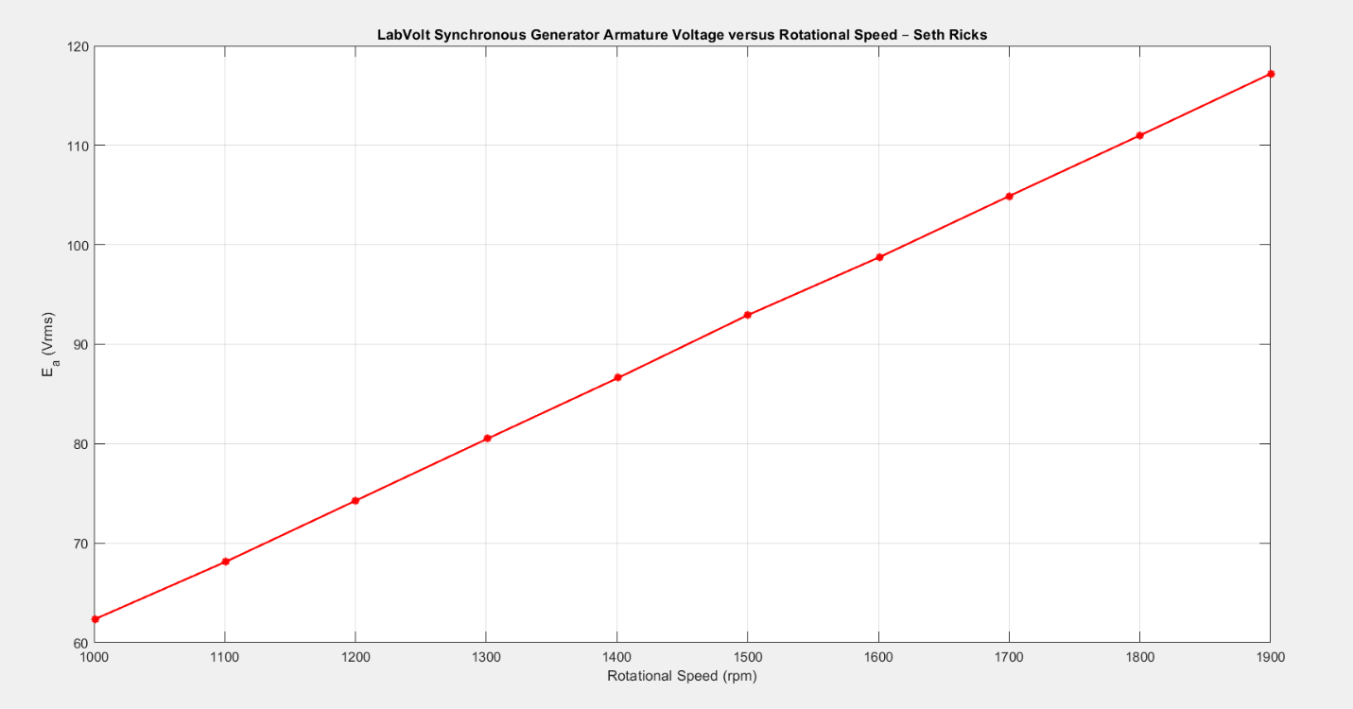
Figure 13: LabVolt Synchronous Generator Armature Voltage versus Rotor rpm.

Generator Performance versus DC Field Current.

- Set the Speed parameter of Four-Quadrant Dynamometer/Power Supply to 1800 rpm.
- Make sure that the switches on the Resistive Load module are set so that the resistance of each of the three resistor banks equals 600 Ω.
- On the Synchronous Motor/Generator, set the Exciter Switch to the open (◯) position and then click on the Start/Stop button in the Four-Quadrant Dynamometer/Power supply Window to start the Dynamometer, making sure the Speed parameter is still set to 1800 rpm.
- Select Edit Record Data, to record the resulting LVDAC-EMS Data Table values, which with the Exciter Switch in the open (◯) position should result in zero I2 field current, although due to measurement imperfections a small offset current may result.
- Next set the Exciter Switch to the closed (|) position on the Synchronous Motor/Generator. Then increase the DC field current I2 in increments of 0.1 A, i.e., 0.1 ±0.003 A, up to a field current value of 0.6 A, recording the resulting measured values in your Data Table for each 0.1 A increment. You will need to adjust both the Synchronous Motor/Generator, Exciter knob and the Power Supply Variable Voltage Control knob to achieve the desired DC field current values. (Note: Use the Synchronous Motor/Generator, Exciter knob as a course adjustment followed by the Power Supply Variable Control knob as the fine adjustment.) The armature current should not exceed 0.7 A, to prevent overheating of the armature windings. When completed, your LVDAC-EMS software Data Table should have 6 rows of data to be passed into Table 3 below.
- After completing the gathering of data for Table 3, click on the Start/Stop button In the Four-Quadrant Dynamometer/Power Supply window to stop the Prime Mover. Next rotate the Exciter Knob to the Min position and rotate the Variable Voltage Control Knob back to 0 on the Power Supply unit.
- In the LVDAC-EMS software Data Table, select File Export Save as type Comma-Separated Values Files (*.csv), which is a file that can be opened in Microsoft Excel, and read by MATLAB for plotting.
- Paste your Generator Characteristics versus Field Current data from the LVDAC-EMS software Data Table into Table 3 below, noting that your Data Table has more columns of data and a different column order than Table 3 below. Hence, you will need to Paste individual columns into Table 3. (Note: The measured dynamometer power values are negative per the passive sign convention, which assigns positive values to dissipated power and negative values to generated power. Also, the total electrical power provided by the three-phase generator is 3P_{a}.) (7 points.)

Table 3: LabVolt 3-Phase Generator Measurements versus Field Current with a 600 Ω Load per Phase.
I2 = I_{f}  (A) | P_{Dyno}  (W) | E1 = E_{a}  (V) | P1 = P_{a}  (W) | P2 = P_{f}  (W)
-0.007 | 2.999 | 0.835 | 0.003 | 0
0.1 | -3.885 | 31.82 | 1.698 | -0.006
0.201 | -17.12 | 57.74 | 5.475 | -0.014
0.301 | -35.02 | 79.68 | 10.77 | -0.022
0.399 | -53.13 | 97.06 | 15.94 | -0.029
0.501 | -70.5 | 110.4 | 20.61 | -0.039
0.599 | -82.83 | 119.4 | 24.18 | -0.05

- Next import your Generator Characteristics versus Prime Mover rpm data into MATLAB for plotting results as shown below in Figure 14.
- From your imported LabVolt Generator Field Current data, plot the armature voltage E1 = E_{a} on the y-axis versus DC field current I_{f} the x- axis. Include an x-axis label of “DC Field Current (A)” using the xlabel() function. Include a y-axis label of “E_{a} (Vrms)” using the ylabel() function. (See MATLAB help on “subscripts in Axis labels”, on the xlabel() function to see how to incorporate subscripts.) Also add a title of “LabVolt Synchronous Generator Armature Voltage versus Field Current – Your Name”. For the armature voltage E_{a} trace include markers for each data point in your plot (Search for plot, i.e., 2-D line plot, and then scroll down to Marker to see how to include data point markers in your MATLAB plot.)
- Replace the figure below with your version. (5 Points.)
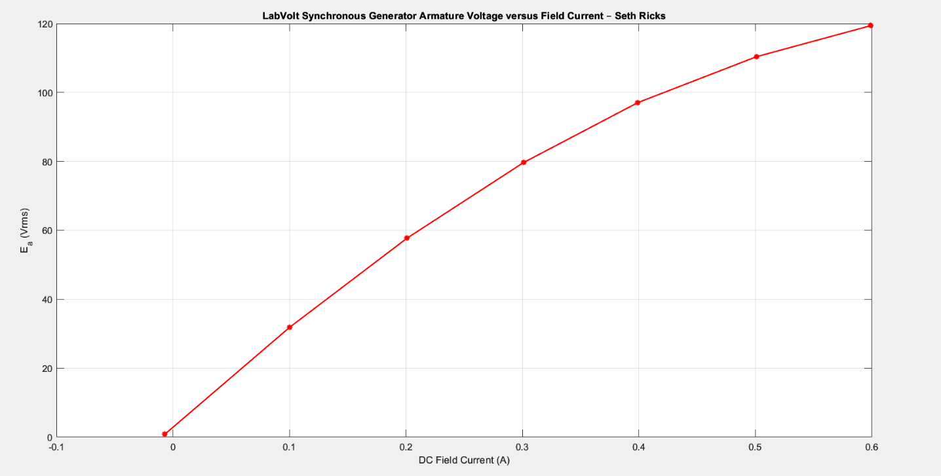
Figure 14: LabVolt Synchronous Generator Armature Voltage versus DC Field Current.

- Close LVDAC-EMS and then turn off all the equipment. Disconnect all leads and return them to their storage location. Be sure to replace the padlock on the main power switch in the LabVolt Power Supply unit.

Discussion and Conclusions Questions: (Note: For the following questions use your own words along with complete sentences. Points are to be deducted for AI generated answers.)

- Using at least three complete sentences, describe three things that you have concluded regarding synchronous motors and generators from this lab. (3 points.)

In both the generator and the motor, speed is directly proportional to voltage. But the torque and the field current in the motor and the generator, respectively, are not linear. I also learned that motors produce negative power, because it takes power to move them, and generators produce positive power, because it takes mechanical energy and turns it into electrical energy.

- Extra Credit Problem: Using at least two complete sentences, describe what causes the nonlinear behavior illustrated in Figure 12. (2 points.)

The iron inside the core of the generator can only be magnetized to a certain extent, and it is not linear. Once it is magnetically “saturated,” it will start to level out, because increasing the current doesn’t do much anymore.

LabVolt Generator Synchronization Lab Grading Rubric: You can work in groups of up to three if desired on this hardware lab. Teams that have four or more persons make working with the equipment difficult. The goal of your lab report is to provide sufficient documentation so that the lab can be repeated if necessary. Therefore, simply add to this document to arrive at your lab report, as all of the explanatory text, procedures, and Discussion and Conclusion questions contained in this document are required for a complete lab report. So for your lab report, add a cover page that includes the name or names, class and name of the lab. Also add in your results, and answers to the Discussion and Conclusions questions to the existing lab document. While you are to share all Procedure items with any lab partners, your Discussion and Conclusions section is to be uniquely yours.
Lab Report Item | Points
Cover Page | 2
Part 1 – Synchronous Motor Testing  Table 1 - (16 points total. 0.2 points per each reasonable value.) | 16
Part 2 – Synchronous Generator  Electrical Frequency f_{e} – (2 points.)  Table 2 - (9 points total. 0.1 points per each reasonable value.)  Figure 13 - (5 points total.)  Table 3 – (7 points total. 0.2 points per each value.)  Figure 14 - (5 points total.) | 28
Discussion and Conclusions | 3
Grammar and Professionalism | 3
Total | 52
Please give feedback on errors you find in this document.

